## **Project 01**

### **Objectives:**

* Create and manage Docker volumes for data persistence.
* Set up a Docker network for container communication.
* Use Docker Compose to manage multi-container applications.
* View and manage Docker logs.
* Deploy the application using Docker Swarm.

### **Project Outline:**

1. **Create Docker Volumes**
2. **Create a Docker Network**
3. **Write a Docker Compose File**
4. **Deploy the Application with Docker Compose**
5. **Manage Docker Logs**
6. **Deploy the Application Using Docker Swarm**

### **Step-by-Step Guide**

#### **1. Create Docker Volumes**

Docker volumes are used to persist data generated by and used by Docker containers.

docker volume create wordpress_data

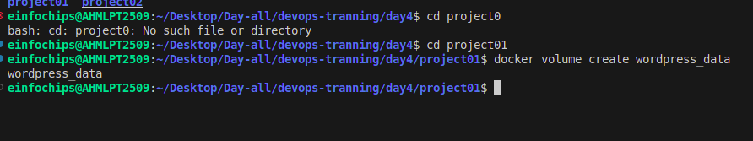

docker volume create mysql_data

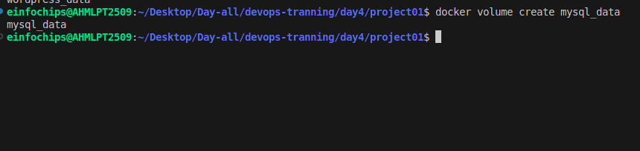

#### **2. Create a Docker Network**

Create a custom network for the containers to communicate.

docker network create wordpress_network

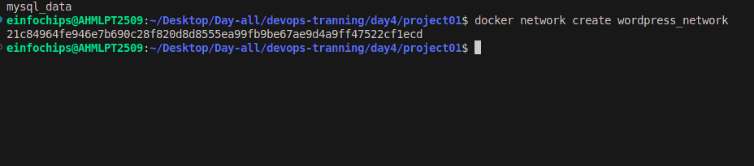

#### **3. Write a Docker Compose File**

Create a docker-compose.yml file to define and manage the services.

version: '3.3'

services:

db:

image: mysql:5.7

volumes:

- mysql_data:/var/lib/mysql

networks:

- wordpress_network

environment:

MYSQL_ROOT_PASSWORD: example

MYSQL_DATABASE: wordpress

MYSQL_USER: wordpress

MYSQL_PASSWORD: wordpress

wordpress:

image: wordpress:latest

volumes:

- wordpress_data:/var/www/html

networks:

- wordpress_network

ports:

- "8000:80"

environment:

WORDPRESS_DB_HOST: db:3306

WORDPRESS_DB_USER: wordpress

WORDPRESS_DB_PASSWORD: wordpress

WORDPRESS_DB_NAME: wordpress

volumes:

mysql_data:

wordpress_data:

networks:

wordpress_network:

#### **4. Deploy the Application with Docker Compose**

Run the following command to start the services defined in the docker-compose.yml file.

docker-compose up –d

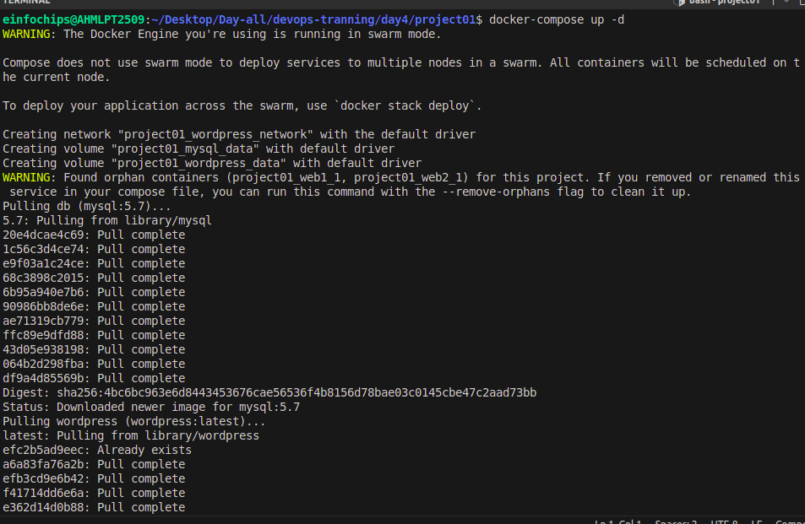

* Verify that the containers are running.

docker-compose ps

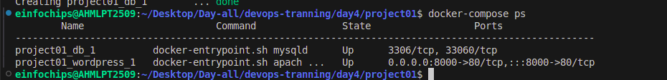

* Access the WordPress setup by navigating to <http://localhost:8000>.

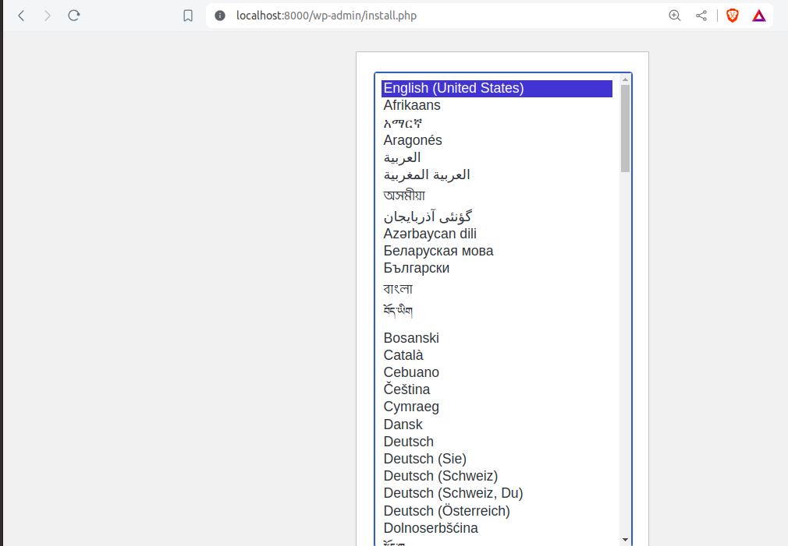

#### **5. Manage Docker Logs**

* View logs for a specific service.

docker-compose logs wordpress

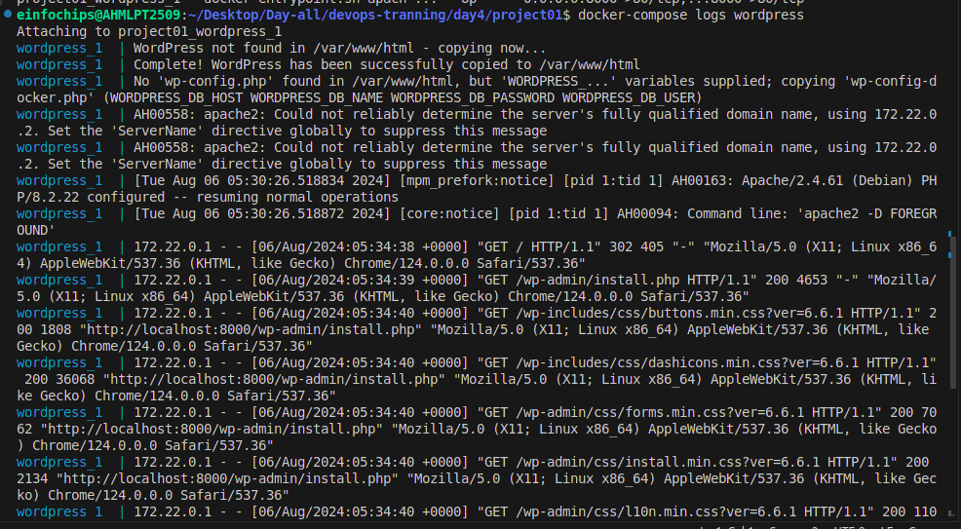

* Follow logs for real-time updates.

docker-compose logs -f wordpress

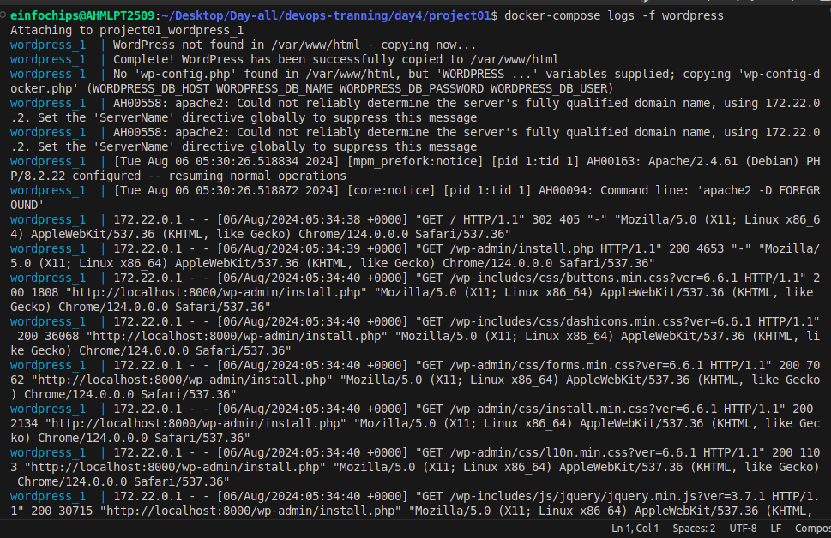

#### **6. Deploy the Application Using Docker Swarm**

Docker Swarm is a native clustering and orchestration tool for Docker.

* Initialize Docker Swarm.

docker swarm init

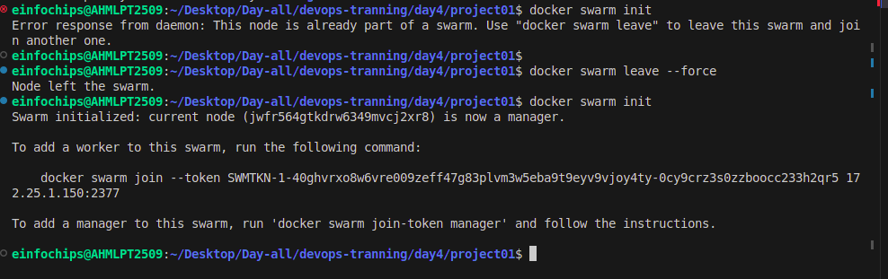

* Convert the Docker Compose file to a Docker Stack file, docker-stack.yml.

version: '3.3'

services:

db:

image: mysql:5.7

volumes:

- mysql_data:/var/lib/mysql

networks:

- wordpress_network

environment:

MYSQL_ROOT_PASSWORD: example

MYSQL_DATABASE: wordpress

MYSQL_USER: wordpress

MYSQL_PASSWORD: wordpress

deploy:

replicas: 1

wordpress:

image: wordpress:latest

volumes:

- wordpress_data:/var/www/html

networks:

- wordpress_network

ports:

- "8000:80"

environment:

WORDPRESS_DB_HOST: db:3306

WORDPRESS_DB_USER: wordpress

WORDPRESS_DB_PASSWORD: wordpress

WORDPRESS_DB_NAME: wordpress

deploy:

replicas: 1

volumes:

mysql_data:

wordpress_data:

networks:

wordpress_network:

* Deploy the stack using Docker Swarm.

docker stack deploy -c docker-stack.yml wordpress_stack

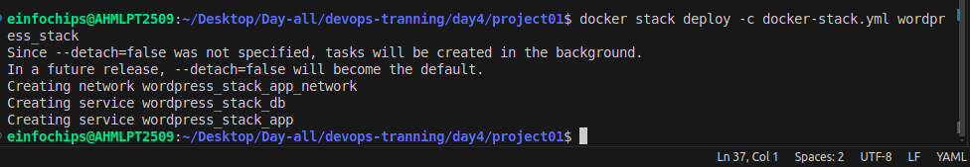

* Verify the stack is running.

docker stack services wordpress_stack

